This page has the codes needed to enter numeric codes when pairing the Scanfob® 2002. It is designed to be folded so that only one code is exposed at a time. Fold the paper in half once vertically, then fold it in half vertically again. Unfold it and fold it in half once horizontally, then fold in half horizontally again. There will be 12 cells separated by fold marks.
- The top row of cells is empty because it contains these instructions.
- The second row contains the numbers 0, 1, 2 and 3
- The third row contains the number 4, 5, 6 and 7.
- The last row contains the numbers 8 and 9 in the first two cells. The next cell is empty. The right-most cell contains the “END” code.

This block contains the number zero.  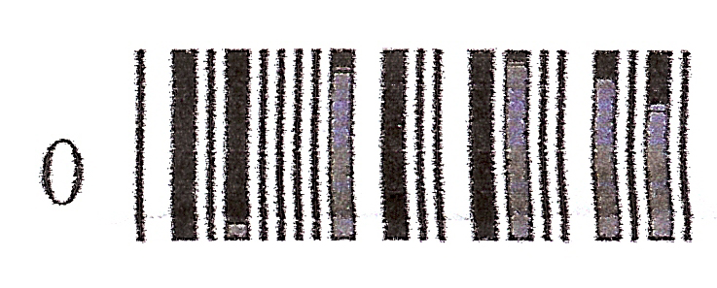 | This block contains the number one.  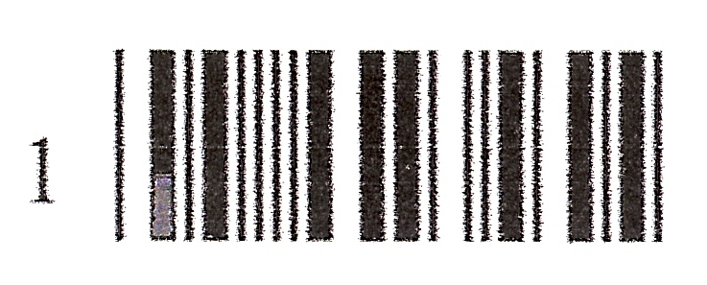 | This block contains the number two.  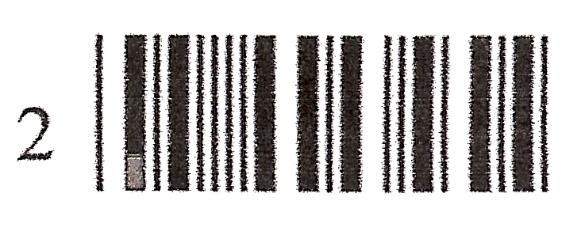 | This block contains the number three.  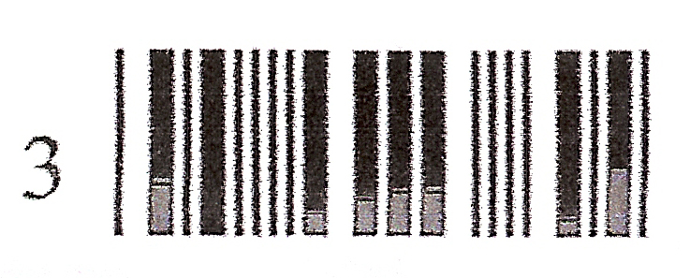
This block contains the number four.  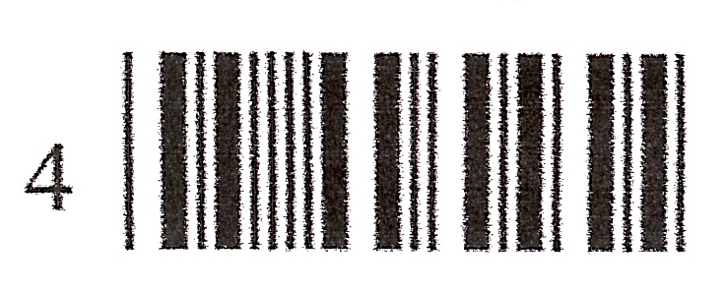 | This block contains the number five  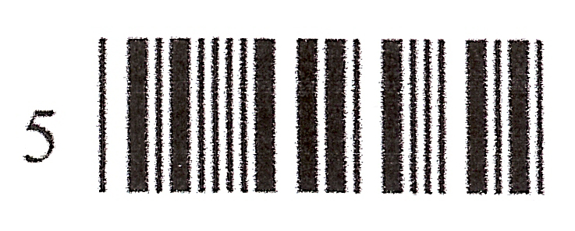 | This block contains the number six.   | This block contains the number seven.  
This block contains the number eight.   | This block contains the number nine   | This block is empty. | This block contains the “END” code  

